As another example, consider the following problem : Given an n× n grid whose each square is either black(1) or white(0), calculate the number of subgrids whose all corners are black. For example, the grid:
 contains two such subgrids: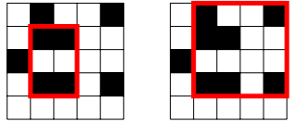
#include <iostream>
#include <vector>
using namespace std;
int main() {
int n;
cin >> n;
vector<int>v(n, 0);
for (int i = 0; i < n; ++i)
for (int j = 0; j < n; ++j) {
int x;
cin >> x;
if (x == 1)
v[i] |= (1 << j);
}
int res = 0;
for (int i = 0; i < n - 1; ++i)
for (int j = i + 1; j < n; ++j) {
int a = __builtin_popcount(v[i] & v[j]);
if (a < 2)
continue;
else
res += (a - 1);
}
cout << res;
return 0;
}

